FOR IMMEDIATE RELEASE

Date: 9/14/2026

Contact: Sarah Nsiah, Health Educator
sarah.nsiah@putnamhealth.com
419-523-5608, ext. 103

Caring for Caregivers: New Wellness Series Offers Support, Connection and Hope

Caring for an adult loved one can be deeply meaningful, but it can also feel lonely and overwhelming at times. Recognizing the importance of caring for the caregiver, a new community partnership is offering free education and support through the “Caring for Caregivers” six-part wellness series.

As part of the Community Health Improvement Plan (CHIP), the series provides space for caregivers to connect with others who understand what they are going through, share experiences, and learn ways to care for themselves along the journey. Most importantly, the hope is that every caregiver feels supported, valued, and a little less alone.

The series is designed for individuals caring for an adult loved one as part of the Community Health Improvement Plan(CHIP) to help social isolation.

Sessions will be held from 2 to 3 p.m. on the second Thursday of each month at Putnam County Homecare & Hospice, 575 Ottawa-Glandorf Road #3, Ottawa starting on Oct. 8th and will end on March 11th, 2027

Each session will include an educational presentation followed by time for caregiver support and connection. Topics were selected based on feedback from local caregivers. A virtual option will also be available for the educational portion of the sessions, with recordings provided for those unable to attend.

The series will be facilitated by Putnam County Homecare & Hospice and Pathways Counseling Center, with the Putnam County Health Department providing support and several educational sessions. Additional partners include the Mental Health, Alcohol & Drug Addiction Recovery Board of Putnam County, Putnam County Council on Aging, Alzheimer’s Association Northwest Ohio Chapter, and The Meadows of Kalida, Leipsic and Ottawa.

The sessions are free and open to anyone caring for an adult. Registration is requested but not required.

For more information or to register, contact Putnam County Homecare & Hospice at 419-523-4449.

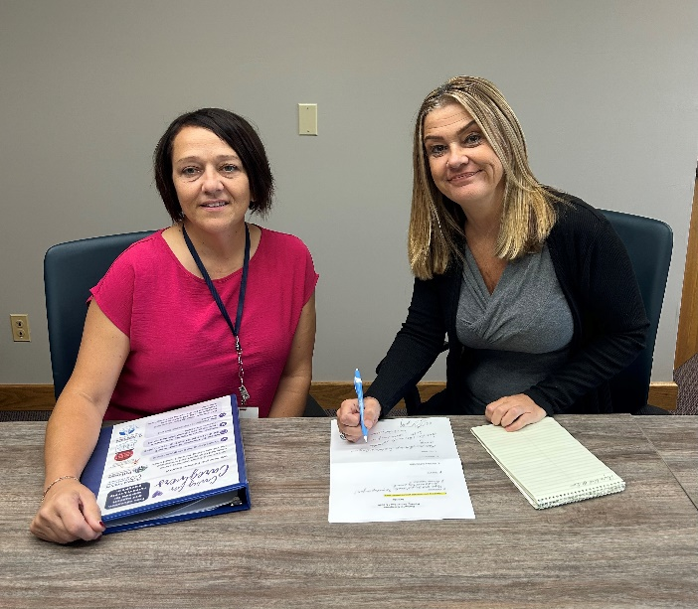

Left to right: The Caring for Caregivers meetings will be facilitated by Myra Warnecke of Putnam County Homecare and Hospice and Fran Leass of Putnam County Pathways Counseling Center pictured above.
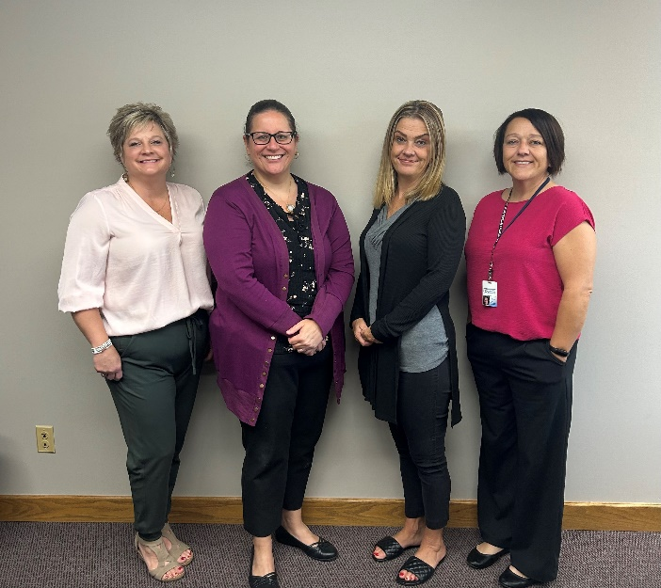

Left to right: Michelle Williamson, Sarah Nsiah, Fran Leass, and Myra Warnecke representing The Putnam County Council on Aging, Putnam County Health Dept., Putnam County Pathways Counseling Center, and Putnam County Homecare and Hospice respectively.

###

